# TMR Injections SSIS solution

## Package Location:

\\sqlrdp\artifacts\dev\com.pharmmd.com.TMRInjections (a version will need to be made in the “\prod\” environment for production

## Solution

TMR injection events need to be added to both Compliance and also PostGres (SCAN, HS or PMD depending on the client). This chain was being done separately so not it has been made into a single solution which requires more manual work than is necessary.

Action Items:

1. There are values in the TMR table in compliance for the Target Quarter and Year for each client. This is loaded via the ole handy ClientParameters table in ETLAutomation on SQLETL with the name of “TMR”. For 2019, we have 9 active MTM Clients so with 4 quarters a year; we expect 36 values in the TMR table for YearRun value of 2019.
2. Insert reference values into the TMRDetail (and TMRCampaignDocument table (if desired)). Also retrieves the Evaluation Date. (the package allows for up to 6 individual entries at a time using a TMRID(x), CREFEvalID(x) and CampaignID(x) combination – there can be blanks as well) There is a configuration file per client with base information.
3. Insert values into the TMRPatientDetail table
4. Insert values into the x_tmr_events table in Postgres using a clientid, target year and target quarter parameter (example: 70, 2019, Q3 – Summacare, 2019 data, Quarter 3)
5. Executes the postgres events injection routine (x_tmr_process_events)

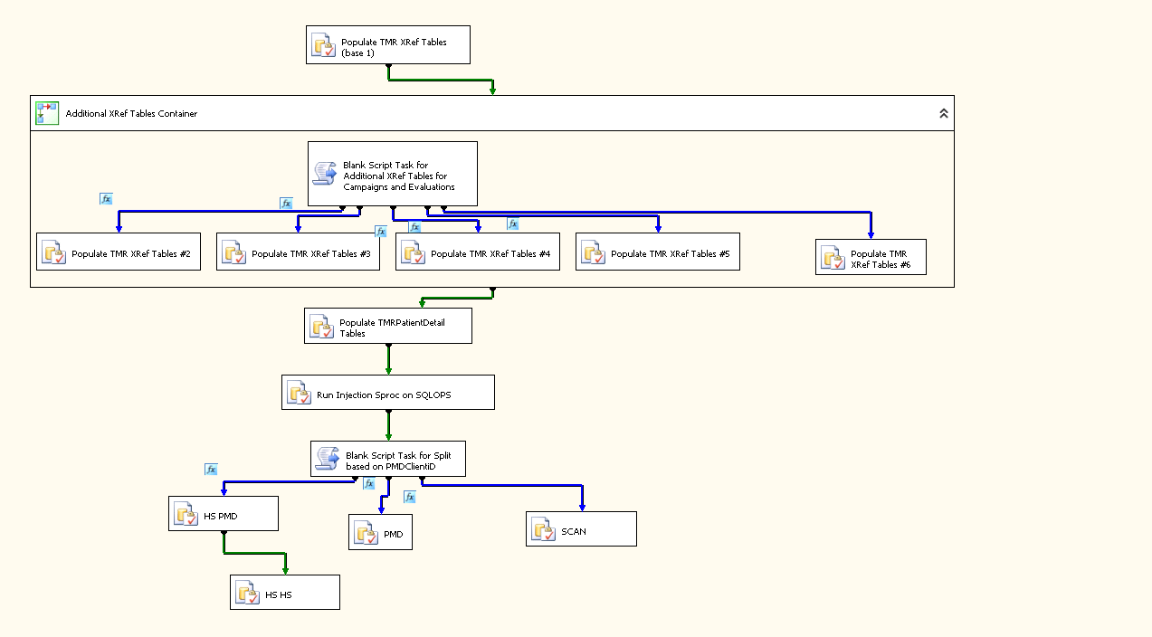

*Figure 1. Package flow*

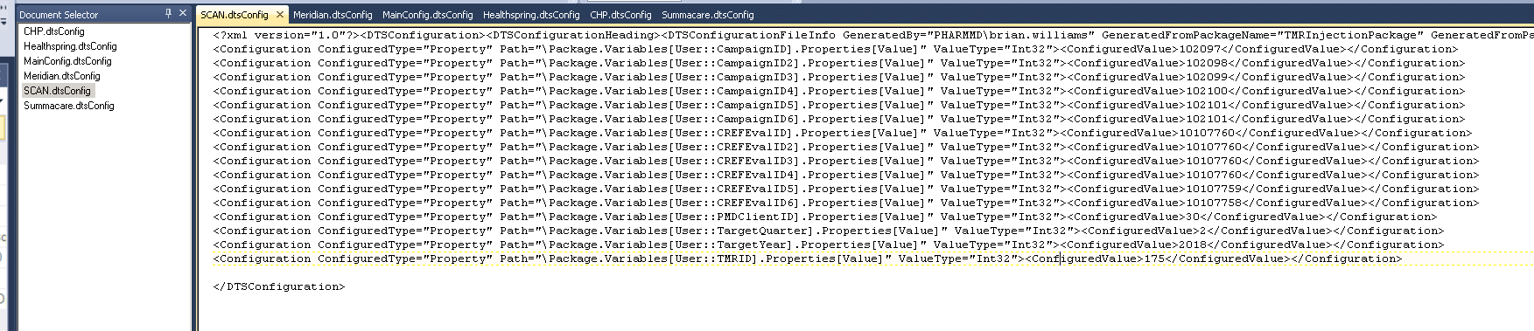

*Figure 2. Configuration Files*

.dtsConfig files to hold the variable values – can be configured per client. Not all of the Evaluation IDs (CREFEvalIDx) are required). Please take note of the TargetYear and TargetQuarters for your execution timeframe. Also, the TMRID and CampaignID (CampaignIDx) values are important. Duplicates are allowed. PMDClientID is also critical to ensure the data goes to the right place (based on PostGres environment)



*Figure 3.* Folder Files

### Removing a TMR run

Because this touches SQL and Postgres, it’s kind of a convoluted process. Steps are described below. This could happen

1. Find the TMRID from the Pivotal Tracker ticket or from the TMR table in Compliance for the proper client, quarter and year
2. Using the TMRID found in #1, run the sproc Compliance.dbo.DeleteSupportingTMRData with the TMRID as the parameter (this will take of ancillary Compliance related data)
3. Go to the proper Postgres environments and server (remember for Healthspring, they are in both PMD and HS environments)
   1. Using the quarter and year from Step #1's TMRID(and take the PMDClientID too), run this query to find the related events (change the year and quarter to match what you need and the client as well (FUTURE DBA addition))
   2. select * from x_tmr_events where yearquarter='2019Q2'and pmdclientid=30; (remember Postgres is VERY case-sensitive so 'Q' is different than 'q')
4. Remove the event records from the events table (unless you have super cool access, you will need a DBA to do this work)
   1. NOTE: You may want to do a 'select count(*)' first to make sure you aren't deleting too many records
   2. delete from events where id in (select event_id from x_tmr_events where yearquarter='2019Q2'and pmdclientid=30);
5. Remove the entries for that quarter from the x_tmr_events table (unless you have super cool access, you will need a DBA to do this work)
   1. NOTE: You may want to do a 'select count(*)' first to make sure you aren't deleting too many records
   2. delete from x_tmr_events where yearquarter='2019Q2'and pmdclientid=30; (remember Postgres is VERY case-sensitive so 'Q' is different than 'q')

# Versioning:

|  |  |  |  |
| --- | --- | --- | --- |
| Version | Date | Author | Note |
| 1 | 9/25/18 | Brian Williams | Initial Version |
| 2 | 2/19/19 | Brian Williams | Need to add in DEV and QA configuration for Postgres and SQL environment |
| 3 | 3/13/19 | Brian Williams | Clarifying a few things |
| 4 | 3/20/10 | Brian Williams | Cleaning up |
| 5 | 8/7/19 | Brian Williams | Adding steps on how to REMOVE a TMR injection run FULLY |